**“Hello World” applications using Fastapi.**

1. Creating application for “Hello World” using Fastapi.

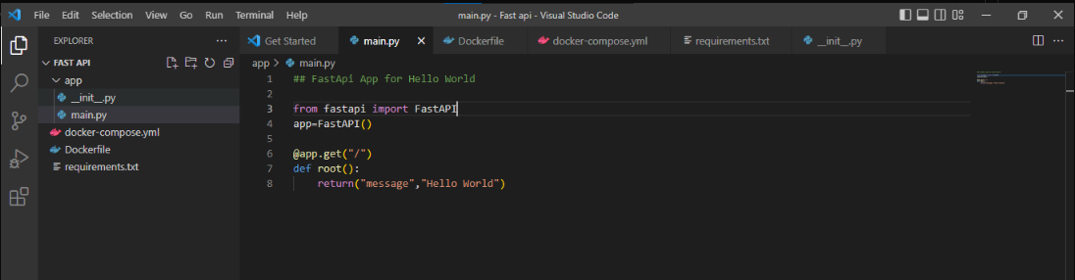

1. Creating Dockerfile.

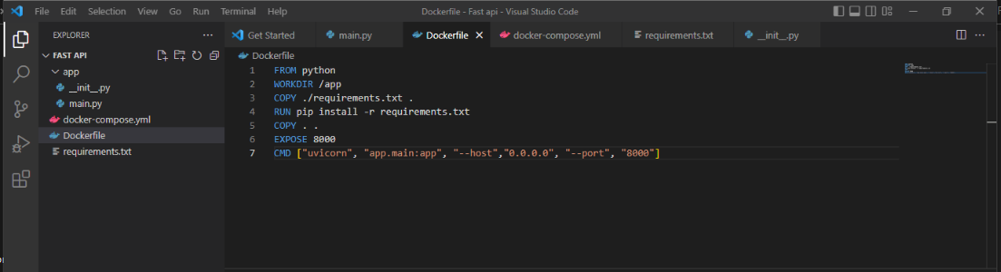

1. Creating Docker compose.yml file.

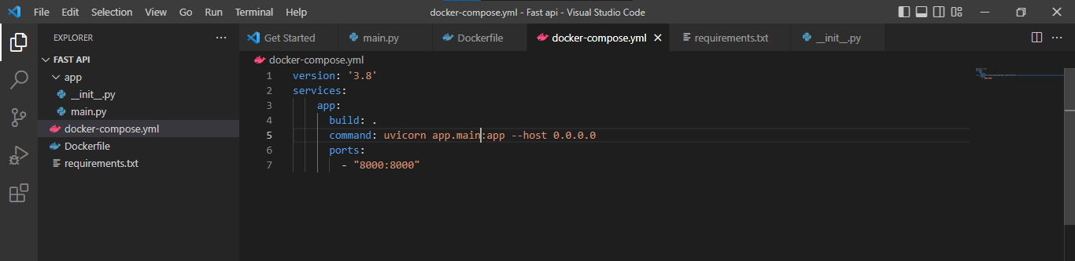

1. Creating requirements.txt file.

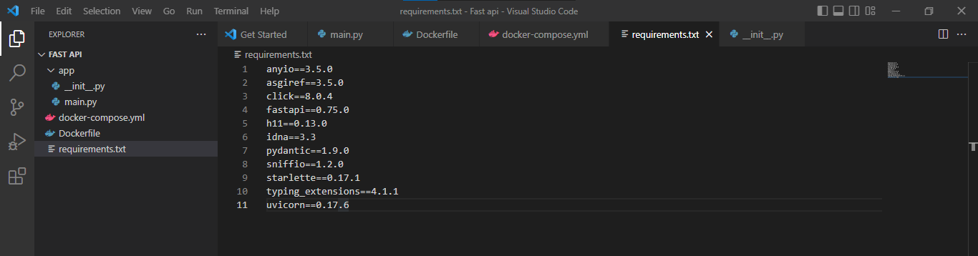

1. Installing requirements.txt applications.

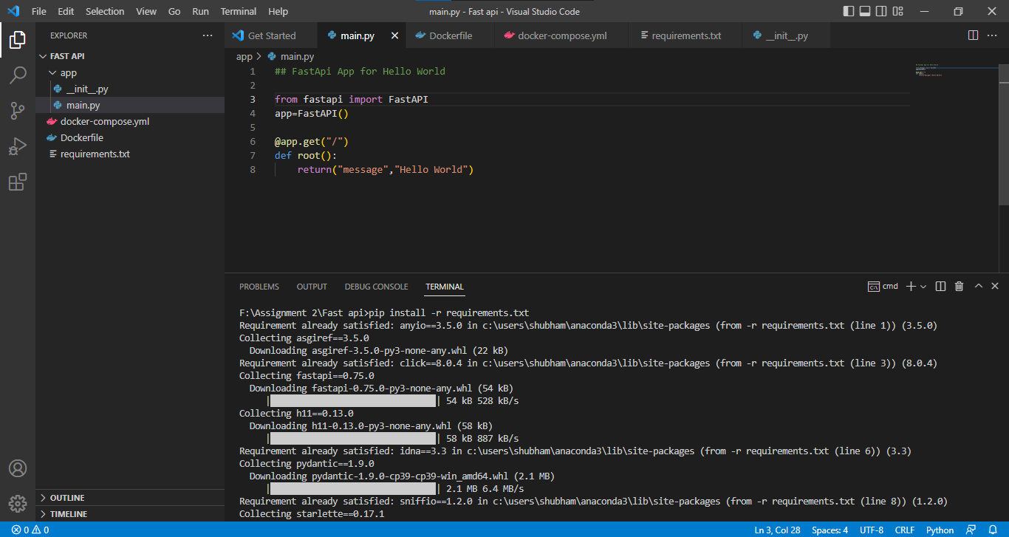

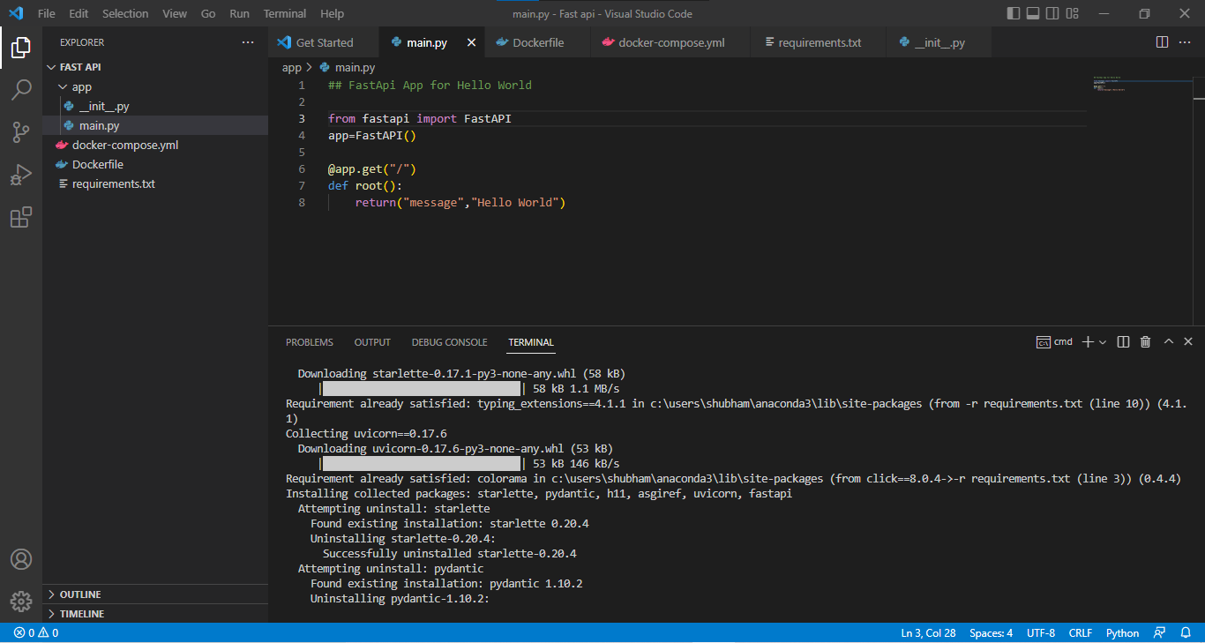

1. Building application in DockerHub.

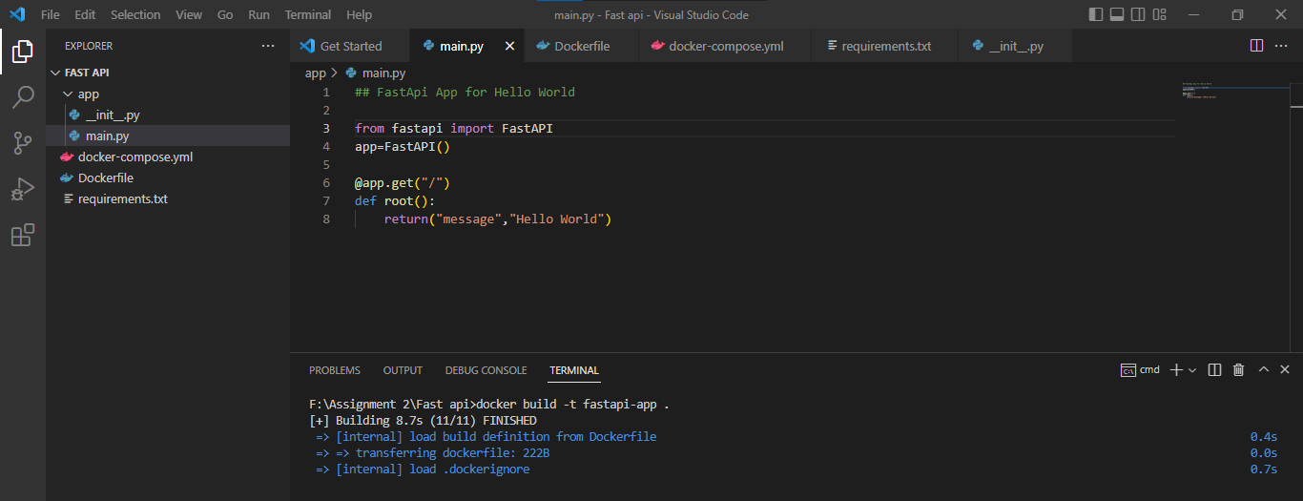

1. Docker images in DockerHub.

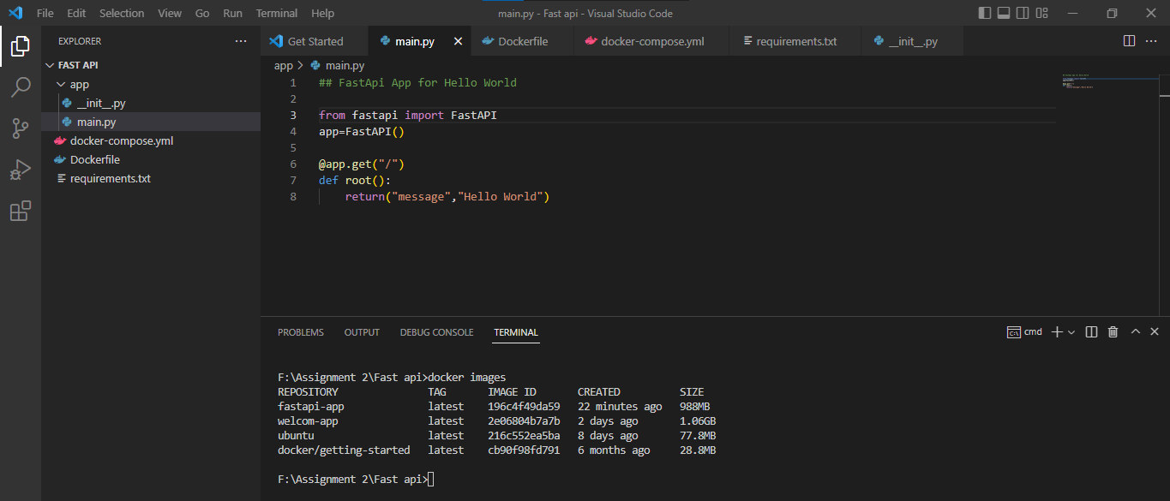

1. DockerHub running containers.

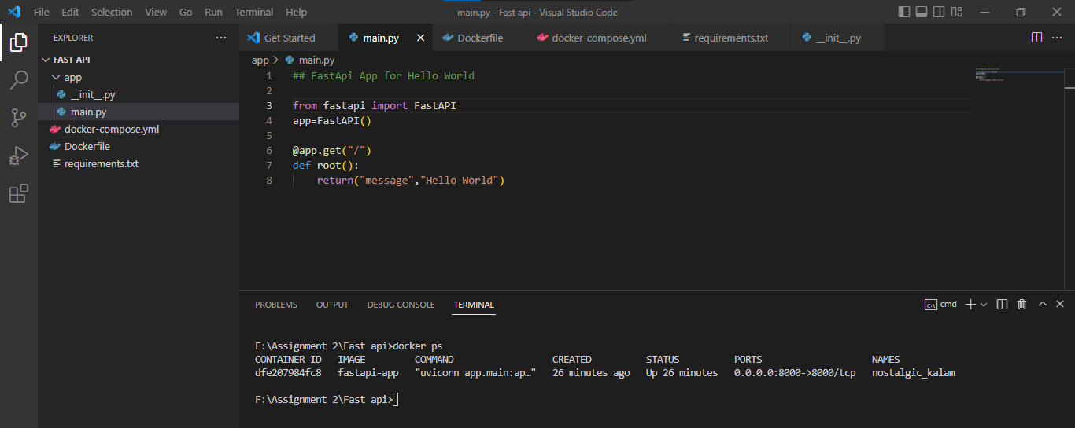

1. DockerHub images in DockerHub.

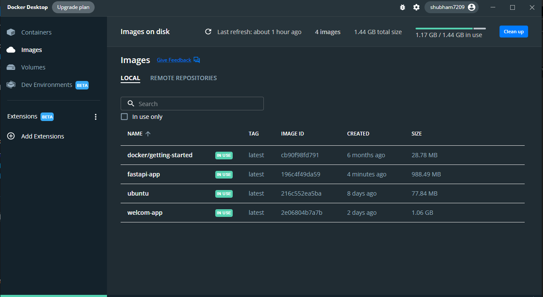

1. Run command to run application locally.

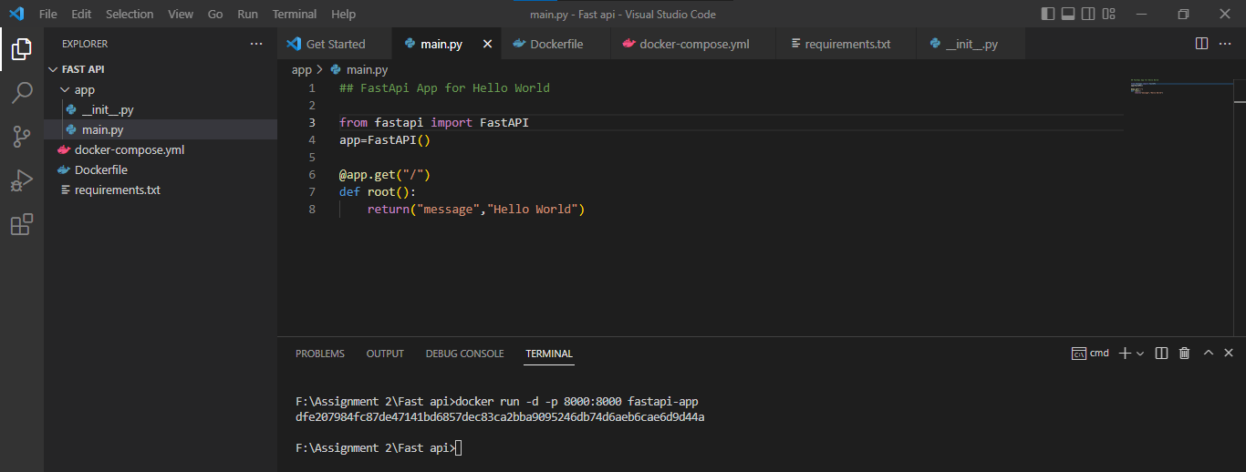

1. Final output in localhost port.

